
BluePlayer User Guide
A Guide for First-Time Users

June 17, 2025
TCN 700 – Technical Writing I

Table of Contents
What is BluePlayer? 2
Features Overview 2
Switching Your Viewing Mode 2
Using Advanced Player Features 3
Player Settings 3
Using Picture-in-Picture and Floating Windows 4
Setting Up Your Sleep Timer 5
Customizing the UI Color Scheme 6
Using Playlists 6
Using Backups and Migration 7

What is BluePlayer?
BluePlayer is a lightweight, all-in-one music player designed for Apple devices. The app features search, play, organize and share functions with music streaming from online libraries like YouTube and Spotify.
BluePlayer allows users to play their favorite songs or videos with enhanced audio capabilities, background & locked-screen playback, offline modes and ad-free listening.

Features Overview
BluePlayer boasts a number powerful and easy-to-use features including:
- Ad-free Viewing Experience
- Music and Video Dedicated Modes
- Advanced Player Features
  - Player Settings
  - Picture-in-Picture (PIP) and Floating Window Viewing
- Sleep Timer
- Customizable UI Color Scheme
- Playlist System
- Backup and Migration Functionality

Switching Your Viewing Mode
BluePlayer offers the choice between Music Mode and Video Mode. Switching between them changes the app’s UI for their different functions.
Music Mode is designed for discovering new songs through personalized recommendations and song playback without video.
Video Mode is designed for discovering videos in a streamlined format similar to popular online video libraries.
To switch your Viewing Mode, follow these steps:
- Navigate to App Settings by tapping the small Wrench icon in the bottom right of the screen.
The App Settings page opens.
- Tap the Switch Mode button in the list that appears.
The Switch Mode page opens.
- Swipe on the slider labelled Switch on for music mode.
  - Slide right to turn on Music Mode.
  - Slide left to turn on Video Mode.

Using Advanced Player Features

Player Settings
BluePlayer’s Player Features are among its most robust qualities, offering a highly customizable listening and viewing experience. The Player Features are outlined below:
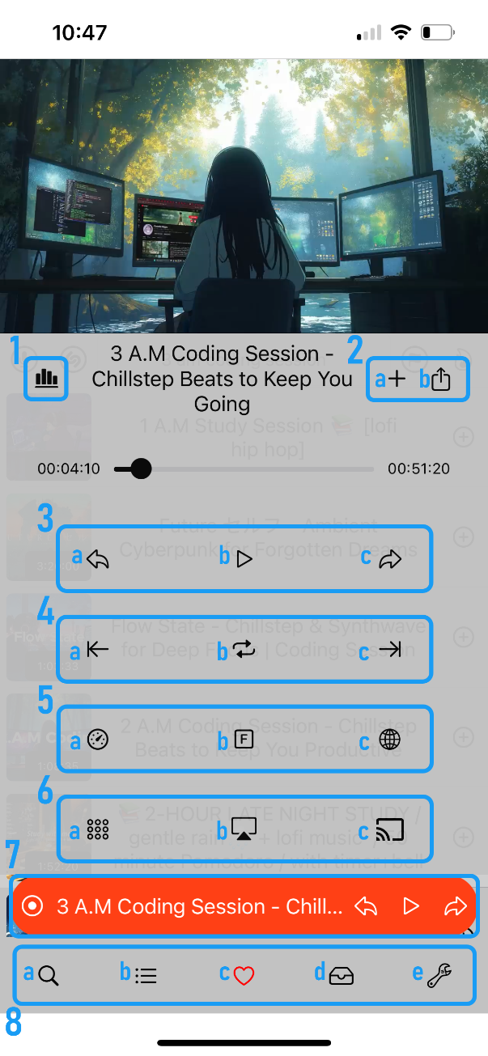
- Equalizer – Used to adjust the audio quality with a high degree of detail.
- Action Bar
  - Add to – Adds the current song/video to your queue or one of your playlists.
  - Share – Allows you to share the current song/video through a link.
- Playback Bar
  - Previous – Returns you to the previous song/video, if one is available.
  - Play – Pauses or plays the current song/video.
  - Next – Plays the next song/video in your queue.
- Adjustment Bar
  - Set Loop Start – Allows you to set a start point on the current song/video to begin a loop.
  - Loop – Plays the selected segment of a loop once a start and end point have been set.
  - Set Loop End – Allows you to set an end point on the current song/video to end a loop.
- Settings Bar
  - Playback Speed – Allows you to set the speed at which your song/video plays.
  - Fullscreen – Toggles on/off Fullscreen mode.
  - Source – Redirects you to the song/video source.
- Video Settings Bar
  - Video Quality – Changes the quality of the current video.
  - Airplay – Toggles the Airplay menu to cast the current song/video to an Apple device.
  - Cast – Toggles the devices casting menu to cast the current song/video to an available TV.
- Quick Bar – Shows what is currently playing and toggles the Player Menu on/off.
- Menu Tabs
  - Search – Opens the Search Menu which allows you to discover songs/videos.
  - Playlists – Opens the Playlist Menu where you can interact with your custom playlists.
  - Favorites – Opens the Favorites Menu which contains your favorited media.
  - Queue – Opens the Queue Menu which shows play order of your songs/videos.
  - Settings – Opens the Setting Menu which contains a list of customizable settings.

Using Picture-in-Picture and Floating Windows
BluePlayer allows you to watch a video while browsing the app or even while outside of the app.
To use Picture-in-Picture mode, follow these steps:
- Open the Search Menu by tapping the Magnifying Glass icon.
The Search Menu appears.
- Search for your desired video by typing in the Search Bar.
- Tap on a video to begin playing it.
Note: If the video does not show, double tap the Quick Bar to bring it up.
- Tap the Quick Bar once to collapse the Player menu.
The Player Menu disappears, revealing the Search Menu while the video continues playing.
To use Floating Window mode, complete steps 1 – 3 above then follow these steps:
- With your video playing, tap the Fullscreen button.
The video begins playing in Fullscreen mode.
- Swipe up from the bottom of the screen to minimize the app
The video continues playing outside of the application in Floating Window mode.
Note: The video will stop playing if you lock your screen.

Setting Up Your Sleep Timer
The Sleep Timer allows you to set a timer that shuts off the current song/video after a specified amount of time. This setting is perfect for users who love to listen to music as they sleep but would rather not have it play all night.
To set up your Sleep Timer, follow these steps:
- Open the Search Menu by tapping the Magnifying Glass icon.
The Search Menu appears.
- Search for your desired song/video by typing in the Search Bar.
- Tap on a song/video to begin playing it.
- Navigate to App Settings by tapping the small Wrench icon in the bottom right of the screen.
The App Settings page opens.
- Tap the Sleep Timer button in the list that appears.
The Sleep Timer page opens.
- Swipe up and down on the Hour and Min wheels to set the length of time after which you would like the song/video to stop playing.
- Once you have selected a time, tap the Start button.
The timer starts and will stop your song/video after the time elapses.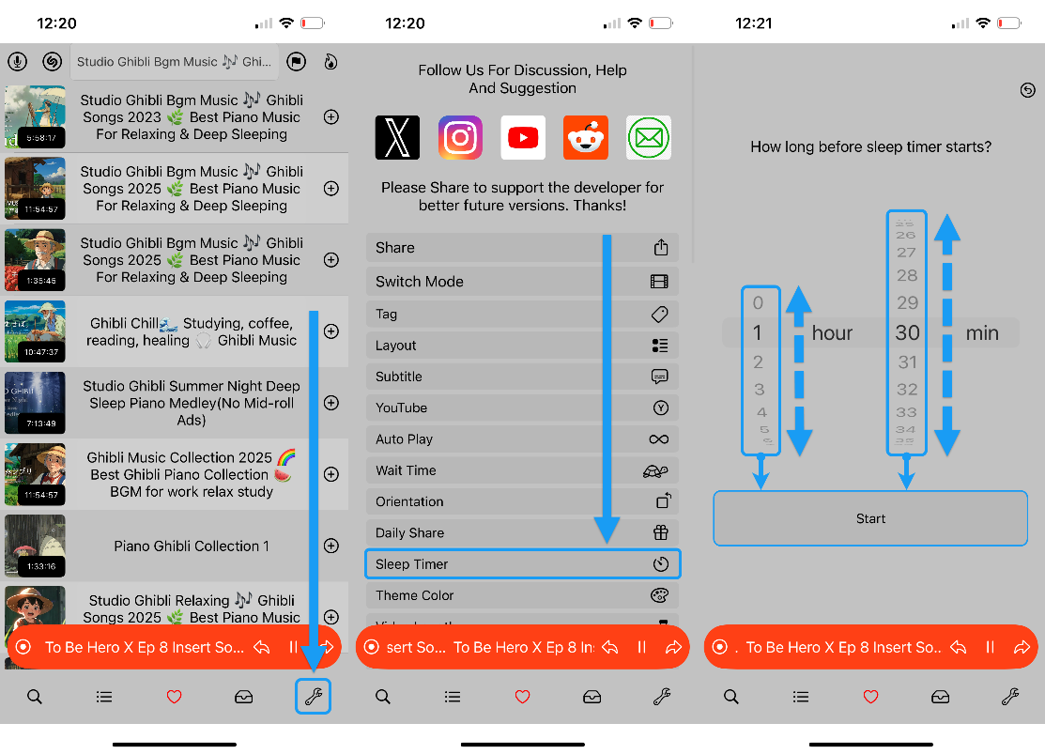

Customizing the UI Color Scheme
BluePlayer allows you to choose from a range of colors to find a theme that fits your preference.
To customize your UI appearance, follow these steps:
- Navigate to App Settings by tapping the small Wrench icon in the bottom right of the screen.
The App Settings page opens.
- Tap the Theme Color button in the list that appears.
The Theme Color page opens.
- You will be presented with 3 options for customization:
  - Skin – Changes the color of the apps persistent background.
  - Control View Toggle Button – Changes the colour of the Quick Bar.
  - Video Toggle Button – Changes the colour of the Video Toggle Button.
Note: Video Toggle Button is only visible in Video Mode.
- Tap the option you would like to edit.
The Color Palette page appears.
- Tap a color of your preference.
- Close the Color Palette page.
The color you chose is now applied.
- Repeat steps 4 – 6 for the remaining options.

Using Playlists
Playlists are a great way to listen to your favorite songs, songs of a particular genre, or simply songs that you prefer to hear consecutively. BluePlayer makes creating Playlists easy and seamless.
To create a Playlist, follow these steps:
- Navigate to Playlists by tapping the Dotted Hamburger Menu icon in the bottom left of the screen.
The Playlist Menu page opens.
- Tap on the Search Bar located at the top of the screen.
The keyboard appears.
- Type a name for your desired Playlist.
- Tap the ‘+’ icon in the top left of the keyboard.
An empty Playlist is created.
To add songs to a Playlist, follow these steps:
- Open the Search Menu by tapping the Magnifying Glass icon.
The Search Menu appears.
- Search for your desired song/video by typing in the Seach Bar.
- Tap on the Circled ‘+’ icon next to your desired song.
The Add To Menu appears.
- You will be presented with 4 options:
  - Play Next
  - My Favorite
  - My Queue
  - [Your Playlist Name]
- Tap on the Circled ‘+’ icon next to [Your Playlist Name].
The Circled ‘+’ icon changes to a Circled ‘✓’ icon and your song/video has been added to the Playlist.

Using Backups and Migration
Backups of your app data are recommended in the unlikely case BluePlayer crashes. Having a recent Backup and Backup Key will make recovery quick and simple.
You can also Import a key to merge libraries together.
To create a Backup, follow these steps:
- Navigate to App Settings by tapping the small Wrench icon in the bottom right of the screen.
The App Settings page opens.
- Tap the Backup and Restore button from the list that appears.
The Backup and Restore page opens.
- You will be presented with 4 options:
  - Key for restore/import
  - Restore
  - Import
  - Backup
- Tap the Backup option.
A Success window opens confirming your successful Backup.
WARNING: Too many Backup attempts will produce an error message. To avoid this, limit your Backups to at least one per hour.
- Close the Success window.
There is now a new option in the bottom of the screen called Share or Copy Key.
- Tap Share or Copy Key.
Your key is now copied to your clipboard.
- Save this key in a safe place.
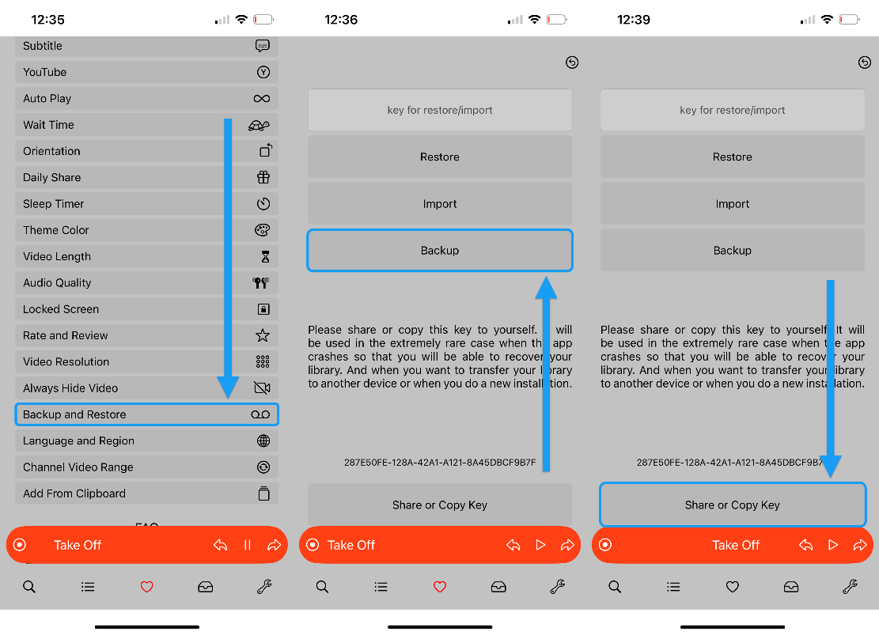
To Restore your library from a backup, ensure you have completed a Backup and performed steps 1 -3 above, then follow these steps:
- Tap the Key for restore/import field.
Your keyboard appears.
- Enter the key you received into the field.
- Tap the Restore option.
A Success window opens confirming your successful Restore.
To Import a key once you have received one, complete steps 1 – 3 outlined in the previous Backup section, then follow these steps:
- Tap the Key for restore/import field.
Your keyboard appears.
- Enter the key you received into the field.
- Tap the Import option.
A Success window opens confirming your successful Import.

